Step 1: Download VirtualBox
Contact OIT for this initial step.

Step 2: Import TracerVM
Once you have VirtualBox installed and opened, you’ll see a window that looks similar to this:
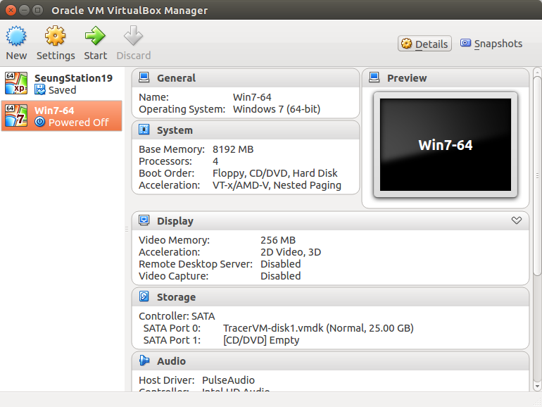
Diagram A. Note: There will be less information on the window in front of you, as the VM hasn’t yet been imported.

Next, move your mouse to the gray bar at the top of your screen. Some options should appear. Click File > Import. A new window should appear that looks like this:
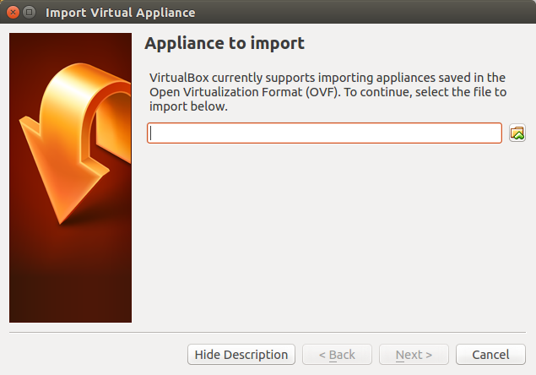
Diagram B
Click the small file button to the right of the address bar, prompting a file window to appear. From the menu on the left, select Omni > TracerVM > TracerVM.ova. This will initiate the import process, which will take roughly 5 minutes to complete. Once it is complete, a window identical to Diagram A will appear, only this time there will be an option called “WIN7 - 64”. Select this option and hit start. The VirtualBox will start up and windows will open on your screen.

Step 3: Map the Network Drive
Once Windows is up and running, select the file selector on the bottom of your screen. In the menu to the left, right click on Network and select Map Network Drive. A new window will appear that looks like this:
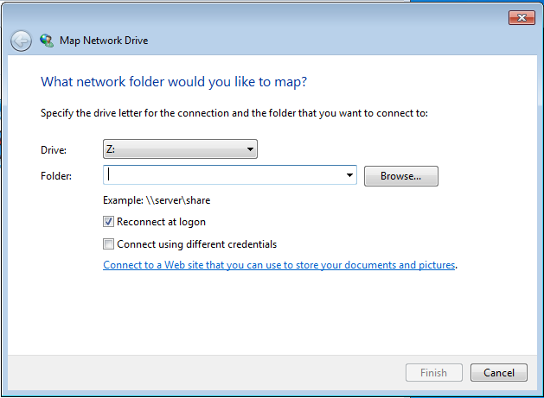
Diagram C

Next, Check the box for “Connect using different credentials. Click in the address bar and type the following: \\bucket.pni.princeton.edu\seung\Omni\TracerTasks. Make sure that the Drive selected is the Z Drive. Hit finish. A new window will appear that looks like this:
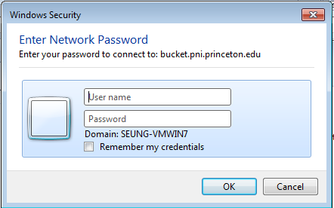

In this next window, enter your pni email and password, and hit OK. VirtualBox should now be set up. Happy Tracing!

